The One With Phoebe’s Cookies

Written by: Sherry Bilsing & Ellen Plummer
Transcribed by: Eric Aasen
703 菲比的饼干配方
钱德开始戴眼镜，大家见怪不怪，因为他们一直以为他戴眼镜。
菲比决定把祖母做巧克力饼干的秘方送给莫妮卡作为订婚礼物，却发现该秘方毁于火灾。
她和莫妮卡着手研究秘方的配料，最终发现那并非原创，而是雀巢饼干。
瑞秋教乔伊航船；在教学中，她变得像她父亲一样刻薄。
钱德为讨准岳父欢心而陪他消闲，两人在健身房尴尬场面不断。
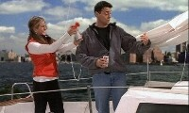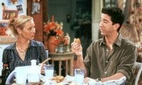
7.03 The One With Phoebe's Cookies
Chandler gets glasses but everyone thinks he had them all along(adv.始终 一直).
Phoebe decides to give Monica her grandmother's chocolate-chip cookie recipe as an engagement present, but discovers it was destroyed in the fire.
She and Monica try to figure out the secret recipe, only to discover that they are Nestle Tollhouse cookies.
Rachel tries to teach Joey to sail his boat;
she turns into her Dad in the process.
Chandler spends time with Mr. Geller, and keeps having embarrassing moments at the gym. [Scene: Central Perk, Rachel, Phoebe, Joey, Ross, and Monica are all there as Chandler enters wearing glasses.]
Chandler: Hey, you guys!
Ross and Rachel: Hey!
Chandler: So, what do you think?
Ross: About what?
Rachel: Yeah, what?
Joey: What?
Chandler: Are you kidding? Okay, I’ll give you a hint; I’ll give you a hint. (Points to his glasses.)
Joey: Eyes! No, no. Your eyes! No. Chandler’s eyes!
Chandler: I got glasses!
Ross: Well, you-you’ve always had glasses.
Chandler: No I didn’t!
Ross: Are you sure?
Rachel: Yeah-yeah, did-didn’t you use to have a pair? They were really round, burgundy, and they made you look kind of umm…
burgundy n. 法国勃艮第红(白)葡萄酒/burgundy 做颜色讲时表示深酒红：一种介于暗灰或暗红色和紫红色或红棕色之间的颜色红葡萄酒的颜色

burgundy

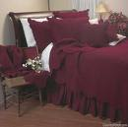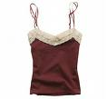

burgundy eyeglass frame

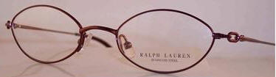
Joey: Feminine.
feminine adj.女孩子气的
Rachel: Yes!
Chandler: No!
Monica: Sweetie, I think the glasses look great. They make you look really sexy.
Chandler: Really?
Monica: Yeah!
Chandler: (sitting down on the arm of her chair) You didn’t think I used to wear glasses, right?
Monica: Of course! (She mouths, "I have no idea," to the rest of the gang.)
Opening Credits
[Scene: Monica, Chandler, and Phoebe's, Rachel, Phoebe, Chandler, and Monica are making some sandwiches.]
Phoebe: So what do you guys want for an engagement present?
Chandler: That’s okay Pheebs, we’re not having a party or anything, so you don’t have to get us…
Monica: (interrupts him) If someone wants to give us a present, we don’t want to deprive them of that joy.
deprive of v.剥夺
Rachel: Oh, y’know what you should get‘em? One of those little uh, portable CD players.
portable CD player
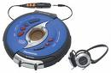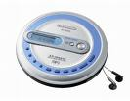
Monica: Oh, I already have one.
Phoebe: Not unless someone borrowed it and left it at the gynecologist.
gynecologist n.妇科医生/Not unless 通常用于轻度的讽刺。直译为：除非……才算没有……

Rachel: Yeah, and-and-and by someone, she means Joey.
Monica: Hey, I know I what I want!
Chandler: What we want honey.
Monica: No, you don’t want this. I want to have your grandmother’s cookie recipe.
recipe n.食谱 (糕饼等的)制作法
Phoebe: You mean the chocolate chip cookie recipe?
chocolate chip cookie n.巧克力薄饼干 曲奇
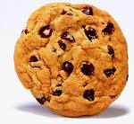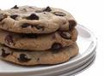
Monica: Uh-huh, yeah.
Phoebe: You mean the one that my grandmother made me swear on her deathbed that I would never let out of our family?
deathbed n.临死所卧之床 临终之时
Chandler: Dying people say the craziest things.
Monica: I wanted it for years! I was gonna make cookies for my children.
Phoebe: Break my heart—Oh, all right.
break sb.'s heart v.使某人很伤心
Monica: Okay. I’m gonna be the mom that makes the world’s best chocolate chip cookies.
Chandler: Our kids are gonna be fat aren’t they.
Joey: (entering) Ahoy!
ahoy int.喂(招呼远处人的声音)
Chandler: Hey! How’s the boat?!
Joey: Great! I’m really getting into this sailing stuff.
Monica: Oh, so you finally took it out of the marina huh?
marina n.小艇码头

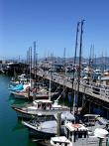
Joey: Why would I do that? It took three guys to get the thing in there!
Phoebe: If you don’t sail your boat, what do you do on it?
Joey: Oh, it’s great! It’s a great place to just kinda, sit, hang around, drink a few beers, eat some chips. (He says that as he sits, hangs around, drinks a beer, and eats a chip.)
chip n.炸马铃薯条 炸洋芋片
Chandler: Well, it’s good that you finally have a place to do that.
Rachel: Y’know Joey, I could teach you to sail if you want.
Joey: You could?
Rachel: Yeah! I’ve been sailing my whole life. When I was fifteen my dad bought me my own boat.
Phoebe: Your own boat?
Rachel: What?! What?! He was trying to cheer me up! My pony was sick.
pony n.矮种马 小马
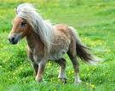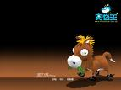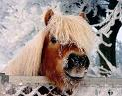
[Scene: Central Perk, Chandler and Monica are there. He takes off his glasses and starts chewing on the ear piece.]
ear piece n.耳承
Chandler: Do you know what I was thinkin’?
Monica: What?
Chandler: Nothing, I just like to go like this. (Does it again.)
Ross: (entering from the bathrooms) Hey Chandler, what are you doing tonight?
Chandler: Uh why, do you have a lecture?
Ross: No, why?
Chandler: Then free as a bird. What’s up?
Ross: My dad wanted to know if you wanted to play racquetball with us.
racquetball
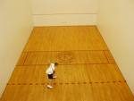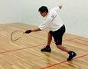
Monica: Wow! That’s great! Dad must really like you, he doesn’t ask just anyone to play.
Ross: Yeah and he didn’t really ask for you, he asked for Chancy, I assumed he meant you.
Chandler: Well, did-did you correct him?
Ross: No, I-I thought it would be more fun this way.
Monica: This is so cool, maybe this is something you can do every week.
Ross: Or you can sit with him on the front porch and make sure no one steals the trash cans. He does that every week too.
front porch
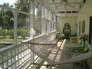
Monica: Oh, just so you know, you-you have to let him win.
Ross: Yeah.
Monica: He hates to lose.
Chandler: Oh no problem, maybe I’ll play with my left hand.
Ross: You’re not a lefty?
lefty n.左撇子
Chandler: Does anybody know me?!
(Phoebe enters, walks up to Monica, and exhales exasperatedly.)
exasperate vt. 使恼怒 激怒(+by/at)[eg: She was exasperated to find nobody at home]/exasperatedly adv.恼怒地
Monica: What’s wrong Phoebe?
Phoebe: I just went to my old apartment to get you the-the cookie recipe and the stupid fire burned it up!
burn up v.烧掉
Monica: No!! Why didn’t you make a copy and-and keep it in a fireproof box and keep it at least a hundred yards from the original?!!
make a copy v.备份/fireproof adj.耐火的 防火的/original n.原物 原著 原稿
Phoebe: (pauses as she figures out how to answer that) Because I’m normal! That was the one legacy my grandmother left me, and I know you wanted it as an engagement present.
legacy n.遗赠(物) 遗产(祖先传下来)
Ross: Oh, we have to get you an engagement present?
Chandler: Don’t worry about it Pheebs.
Ross: No one got me an engagement present.
Phoebe: Okay here ，I don't have the recipe, but here. I wish you health and happiness. (She hands Monica a cookie in a plastic baggie.)
baggie<俚>1)Any plastic "ziploc[n.密封塑料袋(商标名)]" container used to seal up(v.密封住) and seperate product for sale.2) A trademark used for a variety of plastic storage bags. This trademark, often styled(v.称呼) without a final s and in lowercase(n.小写字母), sometimes occurs in print with the meaning "a small plastic bag
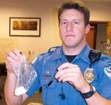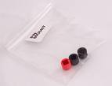
Chandler: An old cookie?
Monica: (To Chandler) This is what happens when you don’t register for gifts!
register v.记录 登记
Phoebe: See no-no, I made a batch and I froze it, and this is the only one left.
batch n.(面包等)一炉
Chandler: We can’t accept this.
Phoebe: Why not?
Chandler:‘Cause it’s gross.
Monica: No! Wait! I think I can figure out the recipe from this cookie! I do stuff like this at work all the time.
Phoebe: Really?!
Monica: Yeah! I bet I can do it.
(Chandler looks over and sees Ross glaring at them.)
Chandler: Okay, we owe you a present.
Ross: Two! I’ve been engaged twice!
[Scene: The Mr. Bowmont (Joey’s boat), she’s shown to be in one of the waterways around New York, but in reality she’s in a sound stage on the Warner Bros. lot and we see New York from the water in some rather poor green screen shots. Rachel and Joey are on board.]
waterway n.水路 航道/sound stage n.摄影棚/Warner Bros。lot 华纳兄弟的片场
greenscreen
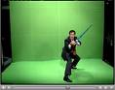
Joey: (drinking a beer) Look at this clown! Just because he’s got a bigger boat he thinks he can take up the whole river. (Yelling) Get out of the way jackass! (To Rachel) Who names his boat Coast Guard anyway?
clown n.粗鲁笨拙(或无知)的人/jackass n.蠢人/Coast Guard<美>国家海岸巡逻队/Coast Guard: 乔伊和瑞秋一起驾船出海，乔伊看到船道上有一个很嚣张的船只，他就对别人大喊大叫，让别人滚开。回过头来，他还乐呵呵地对瑞秋说：“你说什么笨蛋会把自己的船叫做‘海岸警卫队(Coast Guard)’?”事实上，这正是美国海岸警卫队的船只，它在美国海域的地位就相当于路上的警察，乔伊真要知道就不敢惹了。

Rachel: That is the Coast Guard.
Joey: What are they doing out here? The coast’s all the way over there. (Points to the coast, meanwhile there is coast behind him.)
Rachel: Joey, just ignore the boats all right? We’re not finished with the lesson yet.
Joey: All right.
Rachel: Okay, I’m just gonna go over the basic points just one more time, are you ready?
Joey: Come on Rach, not again. I got it! Okay? Let’s start sailing, and I want to go over there (Points) where that boatload of girls is! (Yelling to them) Yo-ho-ho!
boatload n.一船之载货量
Rachel: Oh, okay. Is that what you want to do? You wanna go over and give a little shout out to the old, hot chickas? Okay, let’s do that Sailor Joe. Quick question though, (grabs some of the rigging) what’s this called?
chicka<俚>a sexy latin female

Joey: Uh, boat rope.
Rachel: Wrong! How do you get the mainsail up?
mainsail <船>主桅的帆 主帆
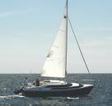
Joey: Uhh, rub it?
Rachel: No. What do you do if I say we are coming about?
come about v.转向
Joey: I’d say, come again. No-no, wait I-I-I know this one, I know this one, uh…
(Rachel blasts an air horn in his ear.)
air horn n.气喇叭
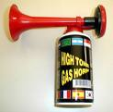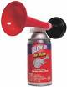
Rachel: Time’s up, now you dead.
Joey: And deaf!
Rachel: Okay, you just go on and make your little jokey-jokes, but if you do not know what you are doing out at sea you will die at sea. Am I getting through to you sailor?! (She punctuates each word by slapping him on the forehead.)
jokey adj.滑稽的/punctuate v.在...中间加标点 强调 突出
Joey: Yes.
Rachel: Don’t just say yes! This isn’t a game, Joey you can really get hurt out here. Okay, so do you want to pay attention or do you want to die?!
Joey: I want to make a ship-to-shore call to Chandler.
ship-to-shore n.自船至岸上之无线电 adj.自船至岸上的
[Scene: Monica, Chandler, and Phoebe's, Monica and Phoebe are trying to determine the cookie recipe by eating small pieces.]
Monica: All right, I definitely taste nutmeg.
taste v.品尝到…的味道/nutmeg n.(肉)豆蔻
nutmeg
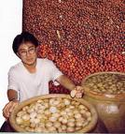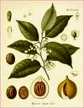
Phoebe: You do?
Monica: You don’t? (Laughs) Well, that’s the difference between a professional and a layman.
layman n.外行
Phoebe: That’s an arrogance.
arrogance n.傲慢自大
Joey: (entering) Hey.
Monica: Hey! How was sailing?
Joey: I don’t want to talk about it. Y’know, you could’ve at least saved me a whole cookie. (He grabs what’s left of the cookie and pops in his mouth.)
Monica and Phoebe: No-wait-no-no!!!!!!!
Joey: (recoils in horror) Women are mean!!! (Storms out.)
Phoebe: I can’t believe that! Now the only thing left of my grandmother’s legacy is this crumb. (She picks it up with her finger and holds it out to Monica.) I wish you a long and happy marriage.
crumb n.碎屑
Ross: (entering with Chandler) Hey.
Monica: Hey! How was it?
Ross: Well I had a great time! Umm, Chancy on the other hand…
Chandler: I will tell the story! It was going great. I let him win. We were bonding. He even said I could call him dad.
Ross: And what did he ask you not to call him?
Chandler: Daddy. All right look, here’s the story. (Flashback to Chandler was about to enter the steam room as he does the voice-over.) Well, we had just finished playing racquetball and we were gonna take a steam. I walk into the steam room and it was really steamy. (The flashback shows his glasses fog up and him trying to find his way around the steam filled room. He takes off his glasses.) So I take off my glasses and that’s when it happened.
steam room n.蒸汽房 桑拿房/voice-over n.画外音/steamy adj.蒸汽缭绕的
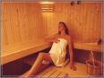
fog up
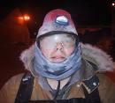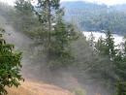
[Cut to the flashback, Chandler’s no longer doing the voice-over.]
Chandler: Guys?
Ross: Over here. (You can see Ross sitting at the far wall.)
Mr. Geller: Have a seat son. (You can see Mr. Geller sitting closer to the door as Chandler walks over and sits in his lap.) Hey!! (Chandler quickly jumps off and sits next to him with a shocked expression on his face.)
Commercial Break
[Scene: Monica, Chandler, and Phoebe's, Chandler is finished telling everyone what happened.]
Monica: Oh my God Chandler! I can’t believe it!
Chandler: I know.
Monica: You gave my father a lap dance!
lap dance
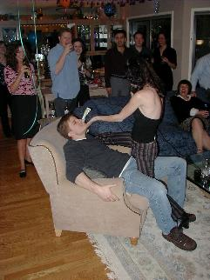
Chandler: Why do they put so much steam in there?!
Ross:‘Cause otherwise they’d have to call it the room room.
Chandler: Why? Okay? Why? Wh-wh-why did that have to happen?
Phoebe: Come on, it’s not that big a deal!
Chandler: Not that big a deal? There…there was touching of things.
Ross: Now, I know you wanted to bond with my dad, but did you really have to bond to that part?
bond with <口>与…相处融洽
Monica: Listen, I’m sure that dad doesn’t care. He probably thought this was funny; he’ll be telling this story for years!
Chandler: I don’t want him to tell this story for years.
Ross: Oh, but he will. He still tells the story how Monica tried to escape from fat camp.
fat camp
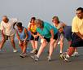
Monica: I wasn’t escaping.
Ross: Then how did you get caught in the barbed wire?
barbed adj.有刺的
barbed wire n.<美>带刺铁丝网
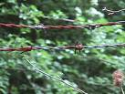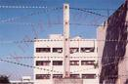
Monica: I was trying to help out a squirrel.
squirrel n.松鼠
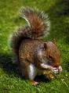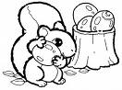
Ross: You were trying to eat it!
(The phone rings.)
Chandler: If that is your father calling to tell this story then the marriage is off!
be off v.取消
Monica: (takes the phone from Ross) Come on. (Answering phone) Hello? (Listens) I’m sorry you have the wrong number. (Listens) (Whispering) Okay, I’ll call you later dad. I love you. (Hangs up.)
[Scene: Central Perk, Chandler, Ross, and Rachel are there.]
Chandler: (getting up) All right, I’m off to see your dad.
Ross: Whoa-whoa, aren’t you a little overdressed?
overdress v.穿得太考究 穿得过多
Rachel: (laughing) Yeah, and-and you better make sure he tips you this time.
tip v.给…小费
Chandler: Look, I figured I would try to convince him not to tell the story anymore, and I figure the best way to do that is face to face—And by face I don’t mean his lap. And by face, I don’t mean my ass. (Exits.)
Ross: (To Rachel) Hey are you getting Monica and Chandler an engagement present?
Rachel: I don’t know. Y’know, they didn’t get us anything.
Ross: Thank you!
Joey: (entering) Hey.
Ross: Hey.
Rachel: Well hello! So, when are we gettin’back out on the water matey?
matey<俚>A word often used by pirates to address friends, aquaintences, or the scurvy(adj.卑鄙的 下流的) low lifes who mopped the deck
Joey: Oh uh, I don’t know the boat way to say this, but uh never!
Rachel: Why not?
Joey: Because! You’re mean on the boat!
mean <俚>凶
Rachel: What? I was just trying to teach you.
Joey: Well, lesson learned! Rachel is mean!
Ross: Yeeeeeep… Yep-yep-yep-yep-yep. I remember when she took me out on her dad’s boat she wouldn’t let me help out at all.
Rachel: Excuse me, I wanted you to help, but you couldn’t move your arms because you were wearing three life jackets.
life jacket n.救生衣
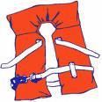
Ross: You have to respect the sea! (Storms off.)
Rachel: Look Joey, I’m sorry if-if you thought that was mean, but I gotta tell ya something. That was not mean. Okay, my father is mean. He used to yell at me all the time on the boat, I mean it was horrible. I was just being a really good teacher.
Joey: Does a good teacher say, "Put down the beer pinhead!?"
pinhead <俚>笨蛋
Rachel: Well, does a good student drink seven beers during his first lesson?
Joey: Six and a half! You knocked that last one out of my hand! Remember?
Rachel: Yeah, I didn’t want you to get hit by the boom!
boom n.吊杆 帆的下桁
Joey: Well it hit me anyway! And it would’ve hurt a lot less if I had finished that last beer.
Rachel: All right, y’know what? I-I’m sorry. I will try to tone it down and uh stop yelling.
tone down v.降低 缓和 柔和
Joey: You won’t boss me around anymore?
Rachel: I won’t boss you around.
Joey: And you’ll be nice?
Rachel: And, I’ll be nice.
Joey: And you’ll be topless?
topless adj.(妇女)袒胸的

Rachel: And—Joey!
Joey: Do you want me to learn?!
[Scene: Monica, Chandler, and Phoebe's, Monica is trying out different cookie recipes. Ross and Phoebe are the tasting group.]
tasting group
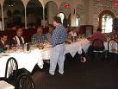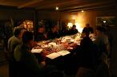
Monica: Okay, here’s batch 22. Ohh, maybe these’ll taste a little like your grandmother’s. This has a little bit of orange peel, but no nutmeg.
peel n.(水果 蔬菜等的)皮
Ross: Let’s give it a shot.
Monica: Okay. Man, I have not made this many cookies since I was in the ninth grade.
Phoebe: Oh, what was that for? Like a bake sale?
A bake sale is a fundraising(adj.筹款的) activity where baked goods such as doughnuts, cupcakes[n.<美>(波纹)纸托蛋糕] and cookies, sometimes along with ethnic baked goods, are sold. Bake sales are usually held by small, non-profit organizations, such as clubs, school groups and charitable organizations(n.慈善组织). Bake sales are often set up around an area of pedestrian(adj.步行的 人行道的) traffic, such as outside a grocery store or at a busy intersection(n.十字路口) near a mall.A major selling point of bake sales is the supposed and often advertised homemade(adj.自制的) nature of the goods being offered, but with the proliferation(n.激增) of prepared[adj.(食物等)经过调制的] cookie dough and boxed muffins and cupcakes, this claim has become increasingly dubious(adj.含糊的).In the United Kingdom the 'bake sale' is known as a 'cake stall' although pies, biscuits and so forth are also available n.烘焙糕饼义卖

Monica: No, just a Friday night.
(They all take a bite.)
Ross: Ohh, these are pretty good.
Phoebe: Yeah, but not as good as batch 17.
Ross: Which one was that?
Monica: The ones we had right after you almost threw up.
Ross: Oh yeah! Batch 17 was good. I did not like batch 16. (Burps a little bit.) I’m okay.
burp v.打饱嗝
Phoebe: Are there anymore from the good batch?‘Cause we could just work off of those.
work off<俚>To get rid of by work or effort
Ross: Yeah, ooh yeah, I think there is one from batch 17 left, uh… (Grabs a cookie and takes a big bite out of it and doesn’t like it.) It’s batch 16! 16 people! Get out of the way! (Gets up and runs for the bathroom.)
get out of the way v.让开 别挡道
[Scene: The Mr. Bowmont, its Joey’s second lesson with Rachel as the resident sailing expert.]
resident adj.常驻的/resident expert n.常驻专家
Rachel: Okay Joey honey, you’re doing really good! All right, now I’m just gonna need you to step to the port side. (Joey pauses as he tries to remember which side is the port side.) Remember? Remember how we talked about the port side?
port n. 左舷/port side n. 左舷/Port side: 这是航海术语“左舷”，问题是这里面没有“左”这个单词，脑筋笨笨的乔伊当然根本判断不出哪里是Port Side了。Port Side 对应的是Starboard(右舷)
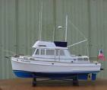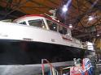
Joey: Ohh yeah.
Rachel: Right?
Joey: Nope.
Rachel: It’s left sweetie, but that’s okay sweetie, that’s a tough one.
Joey: I don’t know why you just don’t say left.
Rachel: Okay, go to the left. (Joey goes starboard or sits on the right side of the boat.) The left!
starboard n.右舷
Joey: Huh?
Rachel: (yelling) Just sit over there!! (Points to the port side.)
Joey: (hurrying over) Okay! Okay, you’re yelling again! See that?
Rachel: No! No-no, no-no-no, very quiet, said with love, no yelling.
Joey: Oh, y’know what? Since I’m here, I think I’m gonna have me a little beer on the port side. (Grabs and opens one.) See what I did there?
Rachel: Okay Joey, we’re luffing a little bit, so could you tighten up the cunningham? (The mainsail has started to flap in the wind and has stopped working efficiently; she wants him to tighten it so that it starts working again.)
luff v.逆风航行/tighten up v.拉紧 使更牢固/In sailing, a cunningham or cunningham's eye is a type of downhaul(n.收帆索) used on a Bermuda[n.百慕大群岛(北大西洋西部群岛)] rigged(adj. 装配帆的) sailboat to change the shape of a sail.It is named after its inventor, Briggs Swift Cunningham II, a victorious(adj.胜利的) America Cup skipper(n.船长), who was a yacht builder and sailor, as well as being a racecar enthusiast, driver, team owner, and racecar owner and builder. The yacht, Columbia, was led to victory by Cunningham in the America Cup competition of 1958. Briggs was inducted into the America Cup Hall of Fame in 1993. He is also in the international and American motorsports halls of fame and when innovating devices for yachting, called on the specialized talents of automobile racing friends to solve problems such as metal stress and selection.The cunningham differs from a typical downhaul in the way that it attaches to the sail(n.帆). The system usually consists of a line which is secured at one end to the mast(n.桅杆) or boom(n.帆的下桁) below the foot of the mainsail. It is then passed through a cringle(n.索眼) in the luff(n. 船首弯曲部)of the sail near the foot, but above the tack[n.(帆的)上下角索], and then led down on the other side to a fitting on the mast or boom or on deck.The tension in the luff of the sail is adjusted using a combination of the halyard[n.(旗帆等的)升降索] and the cunningham (where fitted). The primary advantage of adjusting the cunningham is the speed and ease with which the luff(n.转舵) tension can be changed while sailing or racing. By hauling or easing the line, the tension in the luff can be changed, thereby shifting the point of maximum draft of the sail forward or aft(adv.在船尾), optimizing sail shape—and therefore—performance. It is a fine control which is used more frequently on racing sailboats than on cruising or day-sailing boats.
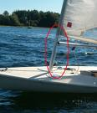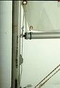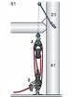
Joey: Uh, wow, you just said a bunch of stuff I didn’t know there.
Rachel: Joey, come on! We just went over this! (She does it instead.)
Joey: Oh, y’know, when we did that was when that bird was flying overhead with the fish in his mouth. Did you see it? It was gross!
Rachel: (angrily) No! All right?! I did not see the bird! I did not see the fish! I did not see the piece of Styrofoam that was shaped like Mike Tyson! I did not, because I was trying to teach you how to sail a boat! Which obviously is an impossible thing to do!
Styrofoam n. 聚苯乙烯泡沫塑料/Mike Tyson 乔伊驾船时老分心，沾染了老爸在船上坏脾气的瑞秋气急败坏：“我没有看见什么鸟，我没有看见什么鱼，我也没有看见那块和麦克·泰森身材差不多的泡沫塑料。我没有看见，因为我在教你如何驾船!”麦克·泰森就是世界前拳王，当时正红火着呢/Michael Gerard Tyson (born June 30, 1966) is a former American world heavyweight boxing champion and is the youngest man to have won a world heavyweight title. During his prime in the late 1980s and early 1990s, Tyson was one of the most recognizable(adj.知名的 妇孺皆知的) athletes in the world. Nicknamed "Iron Mike Tyson," "Kid Dynamite(n.炸药)" and "The Baddest Man on the Planet," Tyson adopted the Muslim name Malik Abdul Aziz, after his conversion to Islam while in prison for his rape conviction. For his behavior both in and out of the ring(n.拳击场), ESPN has ranked Tyson as the #1 Most Outrageous(adj.残暴的) Character in modern sports history by both experts panel(n.专家团 专家小组) selection and internet poll.Trained by Hall of Fame trainer Cus D'Amato early in his career, Tyson unified the belts in the splintered(adj.分裂的) heavyweight division in the late 1980s and won many of his fights by knockout(n.击倒). Tyson knocked out his first 19 professional opponents within six rounds, stopping 12 of them in the first round. He reigned(v.统治) as undisputed(adj.无可置疑的) heavyweight champion for over two years before losing in a shocking upset to Buster Douglas in 1990. He was convicted of raping a beauty pageant(n.盛装游行 选美比赛) contestant in 1992, and after being released from prison in 1995, he engaged in a series of comeback fights before losing in another upset(n.意外的失败), this time to Evander Holyfield. In 1997, his rematch with Holyfield ended when Tyson bit off a portion of Holyfield's ear in retaliation(n.报复) for what he perceived as purposeful headbutts[n.(故意)用头去撞...的腹部]. He fought for a championship again at the age of 35, losing by knockout to Lennox Lewis in 2002. After losing two consecutive bouts(n.较量) to journeymen, Tyson retired from competitive boxing in 2005. He has since engaged in a series of exhibition bouts in a tour across the US to pay off(v.还清债务) his numerous debts; despite making over US$30 million in several fights and $300 million in his career, Tyson declared bankruptcy(n.破产) in 2003.
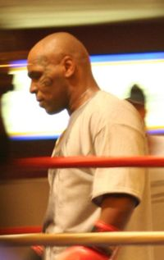
Styrofoam
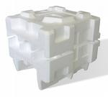
Joey: All right that’s it! You’re yelling and I don’t see you taking your top off! I quit!
Rachel: What do you mean you quit?! You can’t quit!
Joey: Why not?!
Rachel: Because you’re not finished yet and I won’t have it! Greens do not quit!
Joey: Greens? I’m a Tribbiani! And Tribbianis quit!
Rachel: Oh my God, wait did I—I just said Greens don’t quit didn’t I? (Pause) (Angrily) Did I just say Greens don’t quit?!
Joey: Yes! Yes! You did and you’re still yelling at me!
Rachel: No! No! No! I’m not yelling at you, I’m just yelling near you. Oh God Joey, ohh I’m my father. Oh my God, this is horrible! I’ve been trying so hard not to be my mother I did not see this comin’. Oh, Joey, I’m sorry. I’m so sorry. I just wanted you to learn.
Joey: Well, hey I did learn.
Rachel: Really?
Joey: Yeah! Come on.
Rachel: Awww…
Joey: Yeah, it’s okay. I know what a mainsail is. (Points to it. It’s the larger sail.) I know, I know to duck when the boom comes across. I-I know port is right.
duck v.闪避/boom n.帆的下桁
Rachel: Left.
Joey: Damnit!
[Scene: Monica, Chandler, and Phoebe's, the-cookie-trying period has pasted. Monica, Phoebe, and Ross are reflecting on the day’s events.]
reflect on v.思考 反省
Ross: What are we gonna do with all these cookies? Joey.
Phoebe: Y’know, I bet it would actually make my grandmother very happy to know that we’re trying to figure out her recipe. I bet she’s l-l-lookin’up at us and smiling right now.
Ross: Looking up?
Phoebe: Oh yeah—No, she was really nice to me, but she’s in hell for sure.
Monica: Well, I’ve tried everything. I give up. I guess I’m not gonna be the mom who makes the world’s best chocolate chip cookies. I do make the best duck confit with broccoli raab. Kids love that right.
broccoli n.椰菜 球花甘蓝/confit<烹俚>Meat, such as duck, that has been salted and then cooked and preserved in its own fat/duck confit是一种脆皮的鸭肉烹饪菜式/Duck confit (French: confit de canard) is a French dish made with duck legs.While it is made across France, it is seen as a specialty of Gascony. The confit is prepared in a centuries-old process of preservation that consists of salting (with garlic and spices) a piece of meat (generally goose, duck, or pork) and then cooking it in its own fat or broth. Usually the meat is placed in a crock or pot, covered and poached or braised for up to nine hours in its own fat at a temperature not exceeding 250 degrees Fahrenheit/120 degrees Celsius. The cooking fat acts as both a seal and preservative and results in a very rich taste. Confit can be refrigerated up to 6 months.
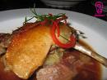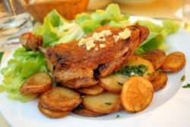
Rapini (also known as Broccoli Rabe (or Raab), Broccoletti, Broccoli di Rape, Cime di Rapa, and Grelos) is a common vegetable in Chinese and Italian cuisine. The plant has various scientific classification designations(n.科学分类术语), including Brassica rapa ruvo, Brassica rapa rapifera, Brassica ruvo, Brassica campestris ruvo, and Brassica rapa rapa (a name normally assigned to the turnip[n.芜箐甘蓝]).Rapini has many spiked(adj.有穗的) leaves that surround a green bud which looks very similar to a small head of broccoli. There may be small yellow flowers blooming from the buds, which are edible.The flavor of rapini has been described as nutty, bitter, pungent(adj.辛辣的), and "an acquired taste(n.嗜好)". The Italian cultivar(n.培育植物) is similar to, but much more bitter than, the Chinese. However the Chinese cultivar(n.栽培变种) is of a lighter green colour, not at all bitter or pungent, and more tender 花菜
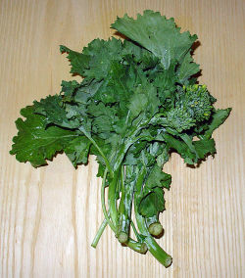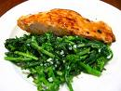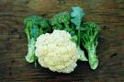
Ross: Aww, Pheeb, come on，isn’t there any relative that would have the recipe? What about, what about your sister?
Phoebe: Oh no-no, no, I made a promise to myself that the next time I would talk to Ursula would be over my dead body. And that’s not happening‘til October 15th, 2032.
over my dead body <口>除非我死了(表示强烈反对)
Ross: That’s the day you’re gonna die? See—darnit, I’ve got shuffleboard that day.
Shuffleboard is a game where players push a small disk(n.圆盘) in a narrow elongated(adj.拉长的) play area with the purpose of positioning it within a marked area. Shuffleboard is traditionally played on one of two scales; Deck Shuffleboard and Table Shuffleboard. 桌掷球
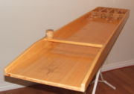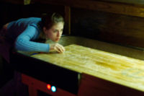
Phoebe: That’s what you think想得美.
Monica: Well, I mean what about friends of your grandmother’s? Wouldn’t they have the recipe?
Phoebe: Well, y’know I may have relatives in France who would know. My grandmother said she got the recipe from her grandmother, Nesele Tolouse.
Monica: What was her name?
Phoebe: Nesele Toulouse.
Monica: Nestle Tollhouse?!
tollhouse n. 通行费征收处/Tollhouse是雀巢旗下的饼干品牌/Nestlé is a multinational packaged food company founded and headquartered in Switzerland. It results from a merger in 1905 between the Anglo-Swiss Milk Company for milk products established by the Page Brothers in Cham, Switzerland, in 1866 and the Farine Lactée Henri Nestlé Company set up in 1867 by Henri Nestlé to provide an infant food product. Several of Nestlé's brands are globally renowned, which made the company a global market leader in many product lines, including milk, chocolate, confectionery(n.糖果), bottled water, coffee, creamer, food seasoning(n.调料) and pet foods.Nestlé's corporate reputation(n.声誉) is one of the highest among Switzerland's largest companies. The company stock is listed on the SWX Swiss Exchange. Some of Nestlé's business practices have been considered controversial, especially the manner in which baby milk has been marketed in developing countries, which led to the Nestlé boycott. 雀巢公司[瑞士]
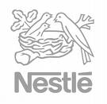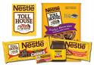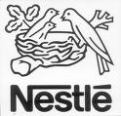
Phoebe: Oh, you Americans always butcher the French language.
butcher vt.屠杀<口>扼杀 弄糟
Monica: (grabbing a bag of Nestle Tollhouse chocolate chips) Phoebe, is this the recipe? (Tosses her the bag.)
Phoebe: (reading the recipe on the back of the bag) Yes!! (Realizes.) Ohh.
Monica: I cannot believe that I just spent the last two days trying to figure out the recipe and it was in my cupboard the whole time!
Phoebe: I know! You see it is stuff like this which is why (Looking down) you’re burning in hell!!
[Scene: The Gym, Chandler and Mr. Geller are heading for the whirlpool room.]
whirl v.旋转/whirlpool n.漩涡 涡流 <专> 旋流按摩浴池
whirlpool room
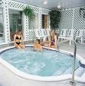
Chandler: So you understand, I’d feel a lot more comfortable if you didn’t tell people what happened. Y’know, I’m a little…I’m a little embarrassed about it.
Mr. Geller: I understand completely, there’s nothing more horrifying than embarrassing yourself in front of your in-laws. As a matter of fact, when I started dating Judy I was unemployed, and her father asked me what I did for a living and I told him I was a lawyer.
in-law n.亲家/be unemployed 失业的
Chandler: What did you do when they found out?
Mr. Geller: They never did, so if ever see me giving them legal advice just nod along. Shall we?
legal advice n.法律上的建议/nod along <口>点头称道
(Chandler nods along and they enter the whirlpool room and remove their robes. Only Chandler is lacking a certain item of clothing. You see this is a coed whirlpool, which means swimsuits, and in fact there are two women already there and Chandler didn’t seem to wear his. Needless to say, everyone is shocked, including Chandler.)
coed adj.对男女都开放的
Chandler: So I guess we wear swimsuits in here!
swimsuit n. (女)游泳衣
Ending Credits
[Scene: The Mr. Bowmont, is tied up alongside the pier; Joey and Rachel are relaxing.]
pier n.(凸式)码头 直码头
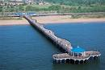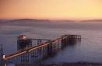
Rachel: Well Joey, I hate to admit it, your way of sailing is a lot more fun.
Joey: Yeah, yeah. Hey, why don’t you give a pull on that rope? (Points.)
Rachel: Ohh we’re not sailing.
Joey: Just pull on it.
Rachel: All right. (She does so and it brings the cooler closer together.) Hey-hey-hey!! (Sees what’s in the cooler.) Sandwiches!
cooler n.(运动型)冷藏箱
Joey: What else还会是什么呢?
Rachel: (hands him one) Here you go.
Joey: Thank you.
Rachel: Oh wow! (She takes a bite, but holds the sandwich vertically so that the stuff falls out.)
vertically adv.垂直地
Joey: What are you doing?
Rachel: Ohh, sorry.
Joey: What you—don’t hold it like that! You’re lettin’all the good stuff fall out.
(More falls out.)
Rachel: Ohh whoops.
Joey: Careful! You’re wasting good pastrami! (Gasps.) Oh my God! I’m my dad!
pastrami n. 腌熏牛肉
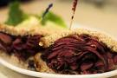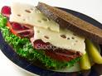
End

